# Question37 Monitor data storage

Case Study

Complete the Case Study

* Background

You are building a modern data warehouse solution for your company.  
  
Consumer and sales data is currently stored in an Azure SQL Database, while the product catalog is maintained in a Cosmos DB backend. The Marketing department also has access to the market research data, published weekly by a third-party vendor on their Amazon S3 storage in CSV format.  
  
The Marketing team wants to use PowerBI as a reporting tool and query against a single consolidated dataset in Azure SQL Data Warehouse. You have internal data scientists who can help with the data transformation and consolidation.  
  
Your company is using Cherwell as its service desk platform. You establish a bi-directional connection between your Azure subscription and Cherwell using a connector from the Azure Marketplace, but you have not used it yet.

* Business requirements

The new data warehouse solution must meet the following business requirements:

* Unauthorized users should not be able to see the contact details of consumers in Azure SQL Data Warehouse.
* System owners want to enforce the data retention policy and every month delete consumers who were not active for more than two years.
* Technical requirements

The new data warehouse solution must meet the following technical requirements:

* Market research data must be copied over to Azure and retained in its original format, storing files in a year and month-based hierarchical structure.
* Incidents with Azure SQL Data Warehouse based on Azure Monitor alerts need to be logged automatically in Cherwell using an existing Azure connection.
* Question 1
* Question 2
* Question 3
* Question 4
* Question 5

## Question 37.1-

You need to select an Azure resource to store market research raw data.  
  
Which resource should you choose?

Azure Managed Disks

Azure Table Storage

Azure Data Lake Storage Gen2

Azure Cosmos DB

## Question 37.2-

You need to enable the required protection of consumer contact details in Azure SQL Data Warehouse.  
  
What should you do?

Enable Transparent Data Encryption (TDE).

Enable row level security (RLS).

Enable Dynamic Data Masking (DDM).

Create a secret in Azure Key Vault.

## Question 37.3-

You create partitions in SQL Data Warehouse to support the monthly deletion of obsolete users.  
  
After uploading the historical data, your team realizes that the date partition needs to be further split. You use a SQL query to perform the task but get an error message for the ALTER PARTITION statement, as shown in the exhibit.  
  
You need to resolve the problem without emptying the target partition.  
  
Which three actions should you perform in sequence? To answer, move the appropriate actions from the list of possible actions to the answer area and arrange them in the correct order.

Possible actions

Actions in order

* Use the ALTER TABLE statement with the SWITCH clause.
* Drop the table.
* Disable the columnstore index.
* Use the ALTER TABLE statement with the SPLIT clause.
* Rebuild the columnstore index.

## Question 37.4-

Your data scientists report that their queries in Azure SQL Data Warehouse often stay in Suspended mode around lunch time.  
  
You need to monitor the execution of the queries using Dynamic Management Views (DMVs) to identify the longest running ones.  
  
Which DMV should you use?

sys.dm_pdw_exec_requests

sys.dm_exec_sessions

sys.dm_pdw_exec_sessions

sys.dm_exec_requests

## Question 37.5-

You are configuring a new rule in Azure Monitor to trigger an alert if the number of the failed connections exceeds 30 within a 10-minute interval.  
  
You need to choose the right action type to log incidents in Cherwell when an alert is fired. You need to configure it with the Portal UI and use the existing connection to the service desk platform.  
  
Which action type should you choose?

Automation Runbook

Azure Functions

IT Service Management Connector (ITSMC)

Push Notification

# Question42 Monitor data storage

Case Study

Complete the Case Study

* Solution Evaluation
* Question 1
* Question 2
* Question 3

**Instructions**  
  
This case study contains a series of questions that present the same scenario. Each question in the series contains a unique solution that might meet the stated goals. Some question sets might have more than one correct solution, while others might not have a correct solution.  
  
Note: You cannot go back or review questions of this type on the actual certification exam.

## Question 42.1-

You are a data engineer for your company. You manage an Azure SQL Database service. You want to monitor the database weekly for performance.  
  
You need to choose a tool or service that monitors the database for performance opportunities through the creation or dropping of indexes.  
  
Solution: You use Query Performance Insight.  
  
Does this solution meet the goal?

No

Yes

## Question 42.2-

You are a data engineer for your company. You manage an Azure SQL Database service. You want to monitor the database weekly for performance.  
  
You need to choose a tool or service that monitors the database for performance opportunities through the creation or dropping of indexes.  
  
Solution: You use SQL Database Advisor.  
  
Does this solution meet the goal?

No

Yes

## Question 42.3-

You are a data engineer for your company. You manage an Azure SQL Database service. You want to monitor the database weekly for performance.  
  
You need to choose a tool or service that monitors the database for performance opportunities through the creation or dropping of indexes.  
  
Solution: You use Azure Advisor.  
  
Does this solution meet the goal?

No

Yes

Case Study

Complete the Case Study

* Solution Evaluation
* Question 1
* Question 2
* Question 3

**Instructions**  
  
This case study contains a series of questions that present the same scenario. Each question in the series contains a unique solution that might meet the stated goals. Some question sets might have more than one correct solution, while others might not have a correct solution.  
  
Note: You cannot go back or review questions of this type on the actual certification exam.

## Question 45.1-

You have an Azure Synapse Analytics SQL pool (data warehouse). Some tables contain sensitive data.  
  
The applicable tables/columns must be discovered and categorized. Access to the sensitive data must be logged and reported.  
  
You need to configure the solution to meet the requirements.  
  
Solution: Perform the following actions:

* Create a Log Analytics workspace.
* Enable database auditing.
* Enable Advanced Data Security.
* Classify the sensitive data.
* Use the built-in Access to Sensitive Data portal dashboard.

Does this solution meet the goal?

No

Yes

## Question 45.2-

You have an Azure Synapse Analytics SQL pool (data warehouse). Some tables contain sensitive data.  
  
The applicable tables/columns must be discovered and categorized. Access to the sensitive data must be logged and reported.  
  
You need to configure the solution to meet the requirements.  
  
Solution: Use the Set-AzSqlServerAuditPowerShell cmdlet.  
  
Does this solution meet the goal?

No

Yes

## Question 45.3-

You have an Azure Synapse Analytics SQL pool (data warehouse). Some tables contain sensitive data.  
  
The applicable tables/columns must be discovered and categorized. Access to the sensitive data must be logged and reported.  
  
You need to configure the solution to meet the requirements.  
  
Solution: Perform the following actions:

* Enable database auditing.
* Create security policies on the tables with sensitive data.
* Write Kusto queries on the auditing data.

Does this solution meet the goal?

No

Yes

# Question114 Monitor data storage -

You are a data engineer. You manage an Azure SQL Database named Sample.  
  
You need to monitor performance by capturing a history of query plan changes over time.  
  
What should you do?

Choose the correct answer

Run the following SQL statement:  
  
ALTER DATABASE Sample SET QUERY_STORE = ON (OPERATION_MODE = READ_WRITE);

Open SQL Server Profiler from SQL Server Management Studio and choose the Performance statistics event.

Run the following SQL statement:  
  
CREATE STATISTICS Sample WITH FULLSCAN

Open SQL Server Profiler from SQL Server Management Studio and choose the Showplan All event.

# Question115 Monitor data storage-

You are a data engineer for your company. You manage a Microsoft SQL Server 2019 database that is hosted on an Azure virtual machine (VM) and used by an on-premises web application. The application is undergoing a major change. You consider using Query Store to examine performance before and after the change.  
  
You need to determine the scenarios where Query Store can help.  
  
For each of the following scenarios, select Yes if Query Store can help. Otherwise, select No.

|  |  |  |
| --- | --- | --- |
| **Scenario** | **Yes** | **No** |
| Creating more indexes on 10 tables |  |  |
| Adding additional databases for the web application |  |  |
| Increasing the size of the VM |  |  |

# Question116 Monitor data storage-

You manage an Azure SQL Data Warehouse. You want to use Dynamic Management Views (DMVs) to monitor your workloads.  
  
You need to find the top 10 longest running queries.  
  
Which view should you use?

Choose the correct answer

sys.dm_pdw_request_steps

sys.dm_pdw_exec_sessions

sys.dm_pdw_sql_requests

sys.dm_pdw_exec_requests

# Question117 Monitor data storage-

You manage an Azure SQL Database. You want to use Dynamic Management Views (DMVs) to monitor your workloads.  
  
You need to be able to easily identify queries within the views.  
  
What should you do?

Choose the correct answer

Run SET SHOWPLAN_ALL OFF.

Enable Query Store.

Use the LABEL option to assign a comment to the query.

Run SET SHOWPLAN_ALL ON.

# Question118 Monitor data storage-

You are a data engineering manager for your company. You manage an Azure SQL Data Warehouse. One of your employees wants to retrieve a list of the last 100 user logins to SQL Data Warehouse.  
  
You need to ensure that the employee has the correct permission.  
  
Which permission should you grant?

Choose the correct answer

VIEW DATABASE STATE

VIEW DEFINITION

ALTER ANY CONNECTION

ALTER ANY USER

# Question119 Monitor data storage-

You are upgrading your company’s online e-commerce solution. You plan to use the In-Memory features of Azure SQL Database to improve the solution’s backend performance.  
  
You convert some disk-based tables into the memory-optimized ones and select the relevant service tier for your Azure SQL Database.  
  
You need to monitor in-memory storage use so that you can verify that Azure SQL Database does not exceed the In-Memory Online Transactional Processing (OLTP) storage cap set for the selected service tier.  
  
Which two actions should you perform to achieve this goal? Each correct answer presents a complete solution.

Choose the correct answers

From the Database -> Monitoring -> Metrics blade, select the In-Memory OLTP Storage percentage metric.

Use the SELECT xtp_storage_percent FROM sys.dm_db_resource_stats query.

From the Database -> Monitoring -> Metrics blade, select the DTU Limit metric.

Use the SELECT max_worker_percent FROM sys.dm_db_resource_stats query.

Use the SELECT max_session_percent FROM sys.dm_db_resource_stats query.

# Question120 Monitor data storage-

You have a Microsoft SQL Server 2019 database hosted on an Azure virtual machine (VM). The database is the data store for a web application. When customers visit the shopping cart page of the application, the page loads slowly.  
  
You need to determine the stored procedure that is being called when this page is accessed.  
  
What should you do?

Choose the correct answer

Choose Include Actual Execution Plan from the Query menu.

Choose Display Estimated Execution Plan from the Query menu.

Create a SQL Server Profiler trace.

Call the SET SHOWPLAN_TEXT statement in Query Analyzer.

# Question121 Monitor data storage - D

You are a data engineer. You manage an Azure blob storage account for your company.  
  
You need to monitor the availability of the account for the past four hours.  
  
What should you do?

Choose the correct answer

Open the blob storage account and create a new alert rule.

Open Azure Monitor and select Storage Accounts from the Insights section.

Open Azure Advisor and create a new advisor alert.

Open the blob storage account and select the Usage tab.

# Question122 Monitor data storage-

You manage an Azure Data Lake Gen1 storage account. You want to log API calls to the account. These logs should be stored in a blob storage account. They should only include detailed operations about the API calls.  
  
You need to configure the Diagnostic settings blade.  
  
To answer, select the appropriate Log and Metric options in the answer area.

Choose the correct options

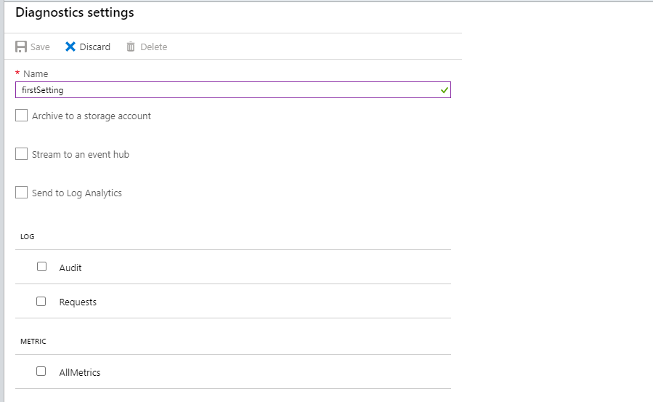

# Question124 Monitor data storage-

You manage an Azure SQL Data Warehouse Gen2 with caching enabled.  
  
Business users report slow performance while running reports. You try to troubleshoot the issue and discover that your working data set does not fit completely into the cache. You solve the issue by scaling up your data warehouse.  
  
You need to implement a monitoring alert that anticipates this situation using Cache hit percentage and Cache used percentage metrics.  
  
How should you configure these metrics? To answer, select the appropriate options from the drop-down menus.

Choose the correct options

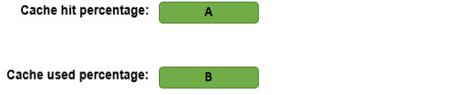

A)

1. High
2. Low

B)

1. High
2. Low

# Question125 Monitor data storage - D

Your company is responsible for a globally-distributed application to support foreign trade operators. This application uses Cosmos DB as the main database, with throughput provisioned on a container level.   
  
Customers are grouped in different tables based on which trade rules they work with. Customers that use a particular trade rule report errors using the application.  
  
You discover that this issue was caused by under-provisioned Requests Units (RU) in this specific trade rule table.  
  
You need to implement an alert using a metric that best anticipates these issues.  
  
Which metric should you use to implement this alert?

Choose the correct answer

Provisioned throughput by container

Total Request Units by container

Request Count by HTTP status code

Max consumed RU per second by partition

# Question126 Monitor data storage-

You implement Azure SQL Database to store sensitive data for your company. Only users from a specified region can access this database.   
  
Because of a compliance requirement, you need to detect unusual access by monitoring access patterns from the database.  
  
You need to configure the Azure SQL Database server to email the compliance department when a potential risk access occurs.  
  
Which three actions should you perform in sequence? To answer, move the appropriate actions from the list of actions to the answer area and arrange them in the correct order.

Create a list in the correct order

Possible actions

Actions in order

* Add a server-level firewall rule.
* Set the Advanced Threat Protection type only for anomalous client login.
* Enable auditing.
* Enable Advanced Data Security.
* Configure the feature to send email alerts to compliance.
* Set the Advanced Threat Protection type only for unsafe action.

# Question127 Monitor data storage-

You work as a Data Engineer for an image processing company.   
  
Users upload files to be analyzed by Azure HDInsight in an Azure Storage Account named Uploads. Files are stored in a blob storage container.  
  
You need to create a report that shows how much data was uploaded in each time frame.  
  
You create a new chart in Azure monitor for this report.  
  
How should you configure this chart? To answer, select the appropriate options from the drop-down menus.

Choose the correct options

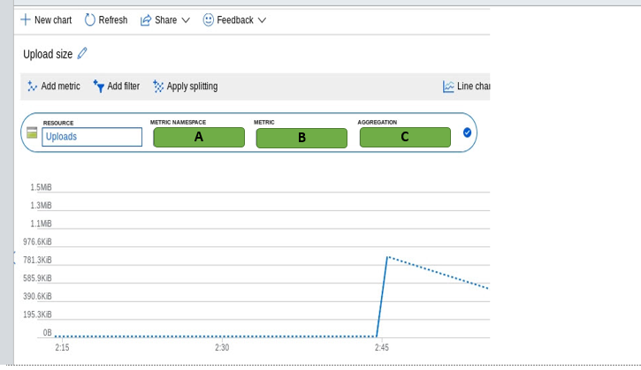

A)

Account

Blob

File

B)

1. Capacity
2. Ingress
3. Transaction

C)

1. Max
2. Min
3. Sum

# Question128 Monitor data storage - D

Your company offers a Software-as-a-Service (SaaS) application for a support ticket system.  
  
Each customer of the application runs in a multi-tenant, isolated database hosted on Azure SQL Elastic Pool Database and uses a Database Transaction Unit (DTU) based provisioning model.  
  
The Sales team starts a campaign to attract more customers, so increasing DTU capacity could be necessary.  
  
You need to monitor this database based on a metric that best anticipates out-of-capacity and performance issues. You also need to minimize the administrative effort to manage this alert.  
  
Which metric should you implement in the monitoring alert?

Choose the correct answer

CPU percentage

DTU percentage

Data IO percentage

eDTU used

# Question129 Monitor data storage-

You manage multiple Azure SQL Databases for an insurance company. These databases are provisioned in a tier of a vCore-based purchasing model.  
  
Th Security team needs to audit all databases and correlate audit logs with logs generated by other Azure services. This analysis should be used to send alerts when suspicious operations occur.  
  
You need to implement auditing in these databases to meet the security requirements while minimizing implementation efforts.  
  
Which two actions should you perform to implement auditing? Each correct answer presents part of the solution.

Choose the correct answers

Configure Azure Event Hub as the audit log destination.

Configure Azure Blob Storage as the audit log destination.

Enable auditing at the database level.

Configure Azure Log Analytics as the audit log destination.

Enable auditing at the server level.

# Question130 Monitor data storage-

You manage a big data solution for a pharmaceutical group. Stores scan customer prescriptions into image files. Each prescription scan is usually 1 MB. The files are stored in Azure Data Lake Storage Gen 2.  
  
The solution uses an HDInsight cluster to analyze the prescriptions in Data Lake Storage. After data is processed, files are moved to the cool tier in Data Lake Storage.  
  
On some occasions, stores upload prescription scans with a higher resolution, resulting in a file size greater than 20 MB. This causes performance degradation in the HDInsight analysis process.  
  
You need to monitor when files uploaded to Data Lake Storage are larger than 20 MB to anticipate HDInsight performance degradation.  
  
Which metric and dimension should you use? To answer, select the appropriate options from the drop-down menus.

Choose the correct options

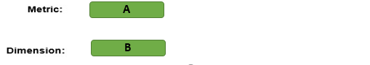

A)

1. Blob Capacity Average
2. File Capacity Average
3. Used Capacity Average

B)

1. Blob Tier
2. Blob Type
3. Response Type

# Question131 Monitor data storage-

You are developing a monitoring solution for an Azure Synapse Analytics SQL pool.  
  
The monitoring solution has the following requirements:

* Query executions must be logged.
* Waits (including queues and blocking waits) must be logged.
* Kusto queries must be used to analyze the logged data.

You create a Log Analytics workspace.  
  
You need to implement the monitoring solution.  
  
Which four actions should you perform in sequence? To answer, move the appropriate actions from the list of actions to the answer area and arrange them in the correct order.

Create a list in the correct order

Actions

Actions in order

* Write Kusto queries using the dm_pdw_sql_requests and dm_pdw_waits tables.
* Enable capturing metrics.
* Write Kusto queries using the AzureMetrics table.
* Enable auditing on the Synapse SQL pool (data warehouse) pane.
* Add a diagnostic setting in the Synapse SQL pool (data warehouse) pane.
* Select Send to Log Analytics.
* Select the ExecRequests and Waits log options.
* Write Kusto queries using the AzureDiagnostics table.

# Question132 Monitor data storage-

You have an Azure Synapse Analytics SQL pool.  
  
You are implementing a data loading process using Polybase. The data must be loaded from Data Lake Storage Gen2. The data is stored in a directory as text files.  
  
One of the external tables has this definition:

CREATE EXTERNAL TABLE [ext].[fact_Order] (

[Order Key] [bigint] NOT NULL,

[City Key] [int] NOT NULL,

[Customer Key] [int] NOT NULL,

[Stock Item Key] [int] NOT NULL,

[Order Date Key] [date] NOT NULL,

[Picked Date Key] [date] NULL,

[Salesperson Key] [int] NOT NULL,

[Picker Key] [int] NULL,

[WWI Order ID] [int] NOT NULL,

[WWI Backorder ID] [int] NULL,

[Description] [nvarchar](100) NOT NULL,

[Package] [nvarchar](50) NOT NULL,

[Quantity] [int] NOT NULL,

[Unit Price] [decimal](18, 2) NOT NULL,

[Tax Rate] [decimal](18, 3) NOT NULL,

[Total Excluding Tax] [decimal](18, 2) NOT NULL,

[Tax Amount] [decimal](18, 2) NOT NULL,

[Total Including Tax] [decimal](18, 2) NOT NULL,

[Lineage Key] [int] NOT NULL

)

WITH ( LOCATION ='/fact_Order/',

DATA_SOURCE = WWIStorage,

FILE_FORMAT = TextFileFormat,

REJECT_TYPE = VALUE,

REJECT_VALUE = 10

);  
  
You receive this error when querying the external table in SSMS:

Rows were rejected while reading from external source(s).

11 rows rejected from external table [fact_Order] in plan step 2 of query execution:

Location: '/fact_Order/fact_Order.csv' Column ordinal: 15, Expected data type: DECIMAL(18,2).

Location: '/fact_Order/fact_Order.csv' Column ordinal: 15, Expected data type: DECIMAL(18,2).

Location: '/fact_Order/fact_Order.csv' Column ordinal: 15, Expected data type: DECIMAL(18,2).

Location: '/fact_Order/fact_Order.csv' Column ordinal: 15, Expected data type: DECIMAL(18,2).

Location: '/fact_Order/fact_Order.csv' Column ordinal: 15, Expected data type: DECIMAL(18,2).

Location: '/fact_Order/fact_Order.csv' Column ordinal: 15, Expected data type: DECIMAL(18,2).

Location: '/fact_Order/fact_Order.csv' Column ordinal: 15, Expected data type: DECIMAL(18,2).

Location: '/fact_Order/fact_Order.csv' Column ordinal: 15, Expected data type: DECIMAL(18,2).

Location: '/fact_Order/fact_Order.csv' Column ordinal: 15, Expected data type: DECIMAL(18,2).

Location: '/fact_Order/fact_Order.csv' Column ordinal: 15, Expected data type: DECIMAL(18,2).

and 1 more...

Msg 107090, Level 16, State 1, Line 1

107090;Query aborted-- the maximum reject threshold (10 rows) was reached while reading from an external source: 11 rows rejected out of total 11 rows processed.

For each of the following statements, select Yes if the statement is true. Otherwise, select No.

|  |  |  |
| --- | --- | --- |
| **Statement** | **Yes** | **No** |
| The data to import contains more than 10 rows that do not conform to the specified external file format (dirty records). |  |  |
| You can use the sys.dm_pdw_errors Dynamic Management View to monitor for this error. |  |  |
| Failed rows will be written to a subdirectory named '_rejectedrows' in the Azure storage account. |  |  |